1. Import required libraries
import pandas as pd
import numpy as np
import matplotlib.pyplot as plt
import seaborn as sns
from scipy import stats

2. Create a sample dataset
data = {
'Student': ['A','B','C','D','E','F','G','H','I','J',
'K','L','M','N','O','P','Q','R','S','T'],

'Marks': [45, 50, 52, 48, 55, 60, 58, 62, 65, 59,
61, 57, 63, 56, 54, 51, 49, 95, 100, 5]
}

df = pd.DataFrame(data)

print(df)

3. Visualize the data using a Box Plot
plt.figure(figsize=(8, 5))

sns.boxplot(y=df['Marks'])

plt.title("Box Plot of Student Marks")
plt.ylabel("Marks")

plt.show()

4. Detect outliers using IQR
Step 1: Calculate Q1 and Q3
Q1 = df['Marks'].quantile(0.25)
Q3 = df['Marks'].quantile(0.75)

print("Q1 =", Q1)
print("Q3 =", Q3)

Step 2: Calculate IQR
IQR = Q3 - Q1

print("IQR =", IQR)

Step 3: Calculate lower and upper limits
lower_limit = Q1 - 1.5 * IQR
upper_limit = Q3 + 1.5 * IQR

print("Lower Limit =", lower_limit)
print("Upper Limit =", upper_limit)

Step 4: Identify outliers
outliers_iqr = df[
(df['Marks'] < lower_limit) |
(df['Marks'] > upper_limit)
]

print("Outliers detected using IQR:")
print(outliers_iqr)

5. Visualize the Outliers
plt.figure(figsize=(8, 5))

sns.boxplot(y=df['Marks'])

plt.axhline(lower_limit, linestyle='--', label='Lower Limit')
plt.axhline(upper_limit, linestyle='--', label='Upper Limit')

plt.title("IQR Method - Outlier Detection")
plt.legend()

plt.show()

6. IQR Outlier Treatment – Capping
One common treatment is capping the outliers at the lower and upper limits.
df['Marks_IQR_Capped'] = df['Marks'].clip(
lower=lower_limit,
upper=upper_limit
)

print(df[['Marks', 'Marks_IQR_Capped']])
For example:
Original Capped
100 Upper Limit
5 Lower Limit
The actual extreme values are replaced by the corresponding boundary values.

7. Visualize before and after treatment
fig, axes = plt.subplots(1, 2, figsize=(12, 5))

sns.boxplot(y=df['Marks'], ax=axes[0])
axes[0].set_title("Before IQR Treatment")

sns.boxplot(y=df['Marks_IQR_Capped'], ax=axes[1])
axes[1].set_title("After IQR Treatment")

plt.show()
This is a very good point in the lab to ask students:
"What happened to the extreme values after capping?"

8. Detect outliers using Z-score
The Z-score tells us how many standard deviations an observation is away from the mean.

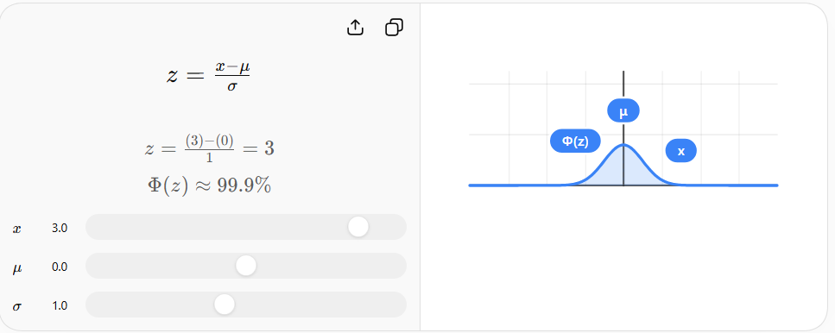

A commonly used rule is:
If |Z-score| > 3, consider the observation an outlier.
Calculate Z-scores:
df['Z_score'] = stats.zscore(df['Marks'])

print(df[['Marks', 'Z_score']])

9. Identify Z-score outliers
z_outliers = df[abs(df['Z_score']) > 3]

print("Outliers detected using Z-score:")
print(z_outliers)
You can also explicitly display the condition:
df['Z_Outlier'] = abs(df['Z_score']) > 3

print(df[['Marks', 'Z_score', 'Z_Outlier']])

10. Z-score Outlier Treatment – Capping
We can replace values whose Z-score is beyond ±3 with the corresponding boundary value.
mean = df['Marks'].mean()
std = df['Marks'].std()

lower_z_limit = mean - 3 * std
upper_z_limit = mean + 3 * std

print("Lower Z-score limit =", lower_z_limit)
print("Upper Z-score limit =", upper_z_limit)

Now cap the values:
df['Marks_Z_Capped'] = df['Marks'].clip(
lower=lower_z_limit,
upper=upper_z_limit
)

print(df[['Marks', 'Marks_Z_Capped']])

11. Compare the three versions
print(df[['Marks',
'Marks_IQR_Capped',
'Marks_Z_Capped']])
You can also visualize them:
plt.figure(figsize=(10, 6))

sns.boxplot(data=df[
['Marks', 'Marks_IQR_Capped', 'Marks_Z_Capped']
])

plt.title("Comparison Before and After Outlier Treatment")

plt.show()

